Supply Chain Management

Directions
- This activity will be done 3 times. 1) a practice round to get you used to the activity. 2) a round with no communication, and 3) a round where you will see all the other supply chain data
- On HuskyCT, open the game that matches your corresponding student number.
  - The student number was assigned in a separate page.
- Play Round 1 which is practice
  - Analyze the results
I did not exactly play very well, trying to get too close to no stock and quickly falling into back orders after a really large order was sustained for longer than I had expected it to be. Despite this I cost a lot less than the others in the chain, and there you can see the CPU manufacturer really got thrown off once I started to buy extra to make up for back-orders.
  - Did you observe a bullwhip effect?
Yes, mostly noted in the people farther from the chain than me. The manufacturer showed the greatest bullwhip effect.
- Play Round 2 with no communication
  - Analyze the results
Yikes, that was going just fine, until there was a sustained period of high orders. I had to keep increasing my orders due to things being on backstock and orders coming in for 40-50 units, until all of the sudden orders dropped off out of nowhere and I was unable to sell off the over 100 units of stock with 0 orders consistently.
  - Did you observe a bullwhip effect?
Yes, it was at the point where people were ordering extra units from me, and the distributor didn’t have any units left to sell, so they kept sending no units my way even though backorders were piling up and more orders were coming in.
- Play Round 3 with Communication
  - Analyze the results
I ended up costing the most because I kept a healthy stock however unlike the other members of the supply chain, however I never had products go on backorder and consistently all of the people in the supply chain had decent stocks and very few items going on backorder. Overall having extra communication really helped prevent major supply chain disruptions, however my stocks stayed fairly high.
  - Did you observe a bullwhip effect?
Yes to some extent, although it was much diminished in this version with communication. When everyone knew along the line when orders were coming no large orders created major disruptions because they were notified at the factory to ramp production immediately.
- Answer the questions below

Questions
- Who controls the supply chain?
Consumers seem to have the most control of the supply chain. Everyone else is either reactive or proactive around the changes in demand and attempting to best match that, however that demand starts at the consumer.
- Is this a push or pull supply chain?
Because the customer was the driving factor in production, this supply chain was a pull supply chain.
- Who has the least flexibility in ordering?
Retailers don’t know exactly what they need, and variance there affects them most since they have the least time to react.
- What happens in reality when there is too much inventory or too little inventory in the supply chain?
If there is too much inventory in the supply chain, the chain is really resistant to changes in orders, however the costs are high all along the chain. If there is too little inventory in the supply chain, large unexpected orders can create back orders throughout the supply chain which have terrible effects on customers and makes manufacturing slow down.
- How is excess inventory removed from the supply chain? How long does it take?
Excess inventory is removed by decreasing sales, but this takes much longer and ends up with low or no orders which need to ripple through the supply chain and lead to manufacturing downtime.
- Which link in the supply chain should have the most inventory?
The retailer should have the most extra supply inventory, because if they stop the fires of high demand early on, they can adjust their orders by only 1-2 units incrementally allowing the rest of the supply chain to react slowly as well.
- What could you have done to help manage your orders better?
I could have managed orders better by keeping a stronger supply without information, and ordering much earlier with information. As a retailer, I should have kept more stock to prevent backorders, as retailer backorders take much longer to solve than other backorders in the supply chain.
- Compare your results between Round 2 and Round 3. Did you improve? Was the bullwhip effect less or more?
The bullwhip effect was less in the round with communication, as we all kept healthy stocks and were able to react early to shifts in demand making the supply match demand most of the time. Round 2 without communication, small problems became large problems very quickly, and there were some rounds where I couldn’t buy anything because my distributor was out, and couldn't service my customers because my stocks had run out.

Useful Resources
The following order demand map outlines the ordering process.

Order/Demand Map
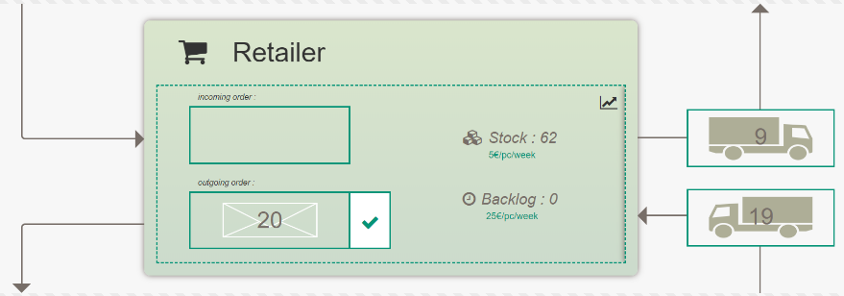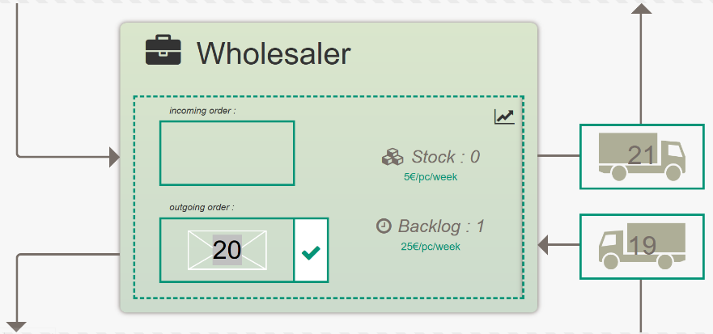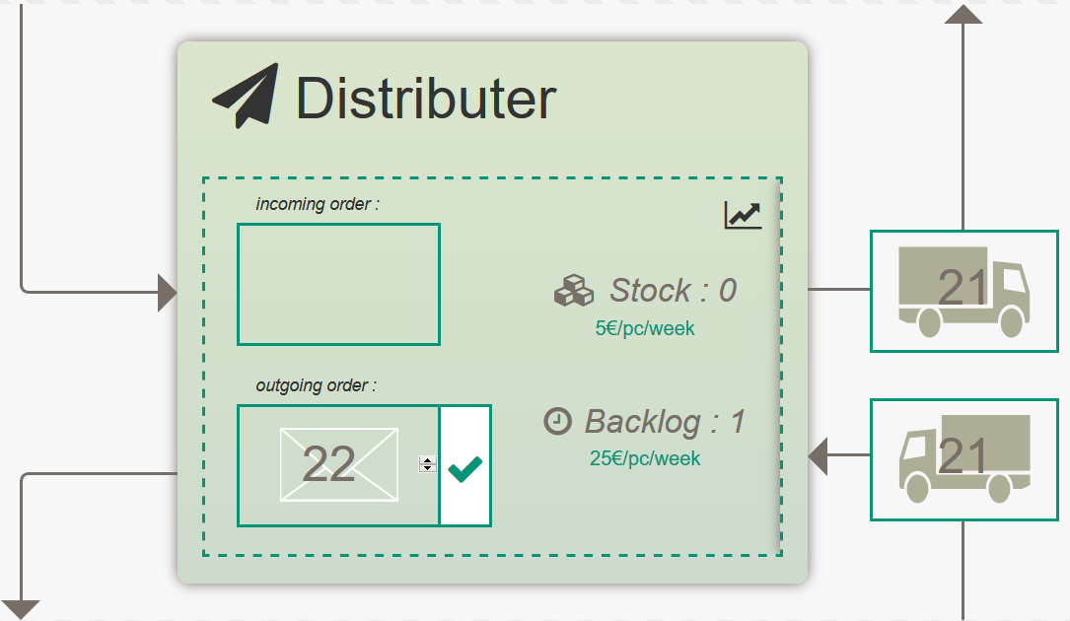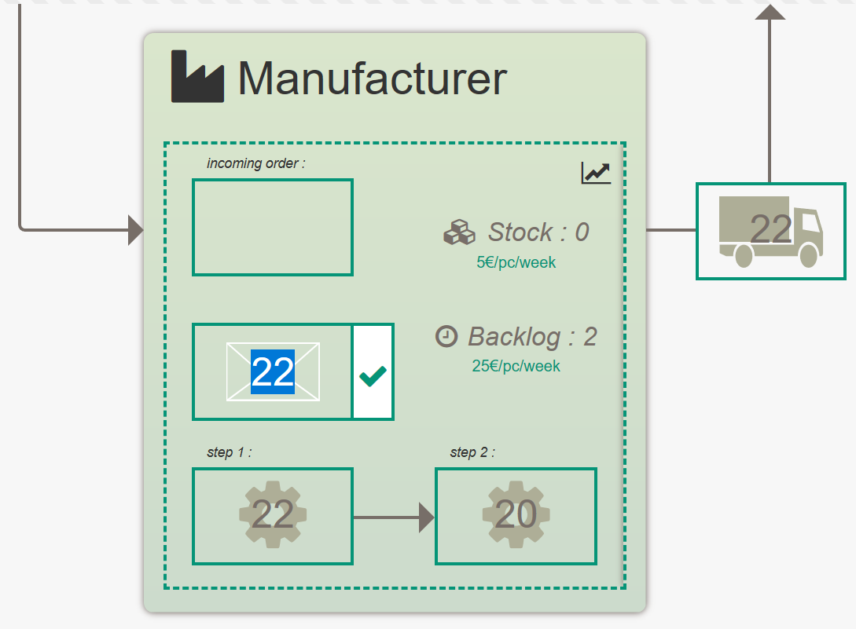

Results Summary
Below is the results screen that will appear at the end of the simulation.
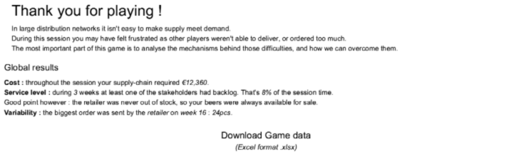
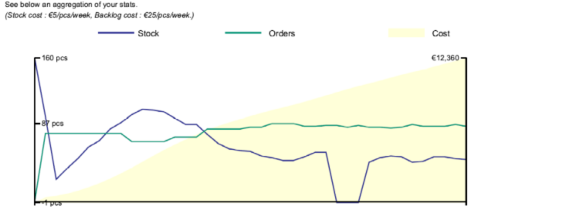
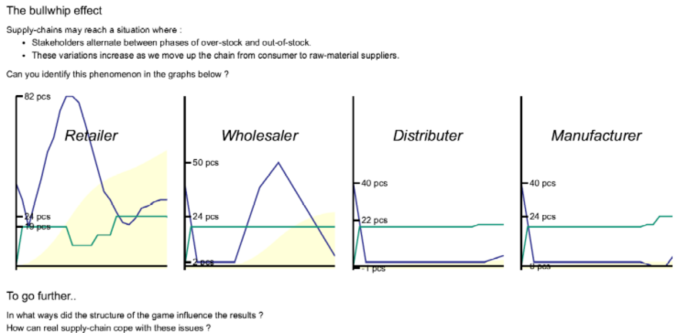

Bullwhip Example
The example below shows a potential bullwhip effect. Note that the Y-axis changes as the orders move through the supply chain.
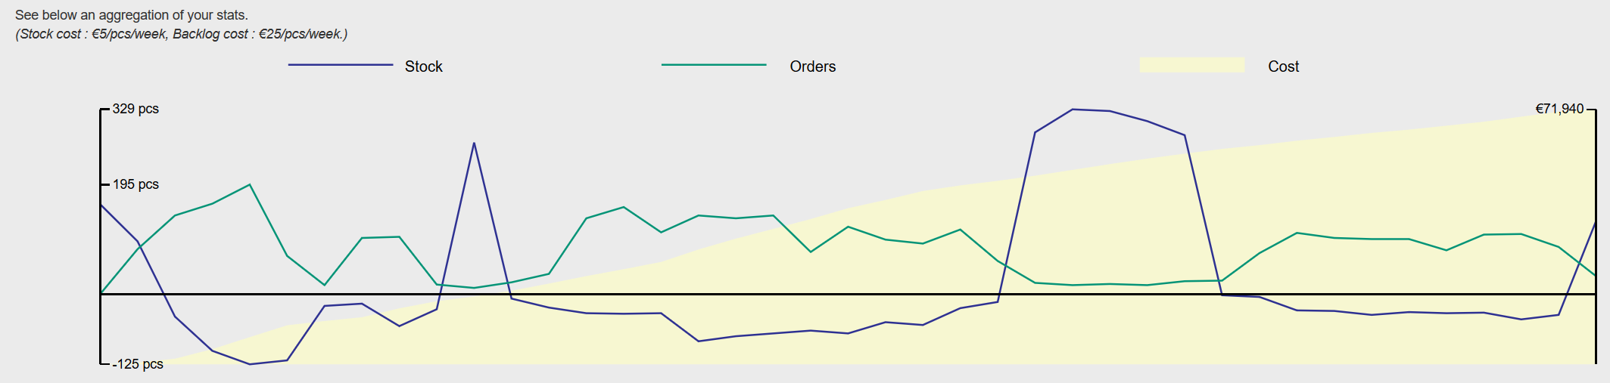
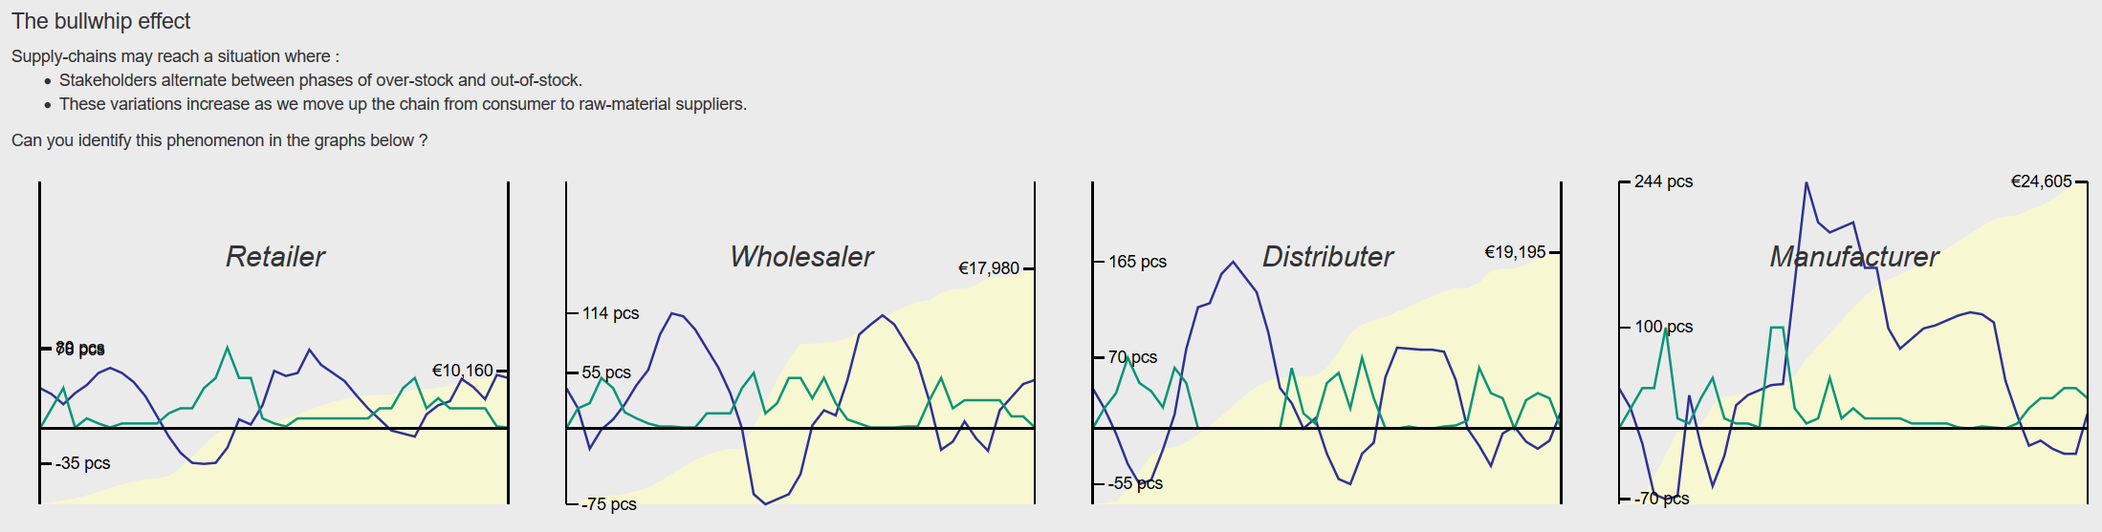

OPTIONAL READ – Detailed directions based on the paper version

Introduction to the Beer Game
In this game you play as an actor of the distribution network of a beer company. It lets you experience the classical coordination problems met by operation managers. It is a good introduction towards supply-chain reform & innovation.
For more information about the Beer Game visit www.beergame.org

Purpose
The purpose of the Beer Game is to experience systemic effects and to introduce the need for supply chain and network management. Specifically it shows:
- How single parts in a system influence each other.
- How individual thinking differs from systemic thinking (network thinking).
- Potentials for systems optimization and the use of information systems.

The Beer Game setup
The Beer Game supply chain consists of four stages:
- The retailer (pink) has to fulfil the end consumer’s orders.
- The wholesaler (orange) has to fulfil the retailer’s orders.
- The distributor (green) has to fulfil the wholesaler’s orders.
- The factory (blue) has to produce the beer to fulfil the distributor’s orders.

The Beer Game is played in groups of 4, each person plays one supply chain stage (see figure).

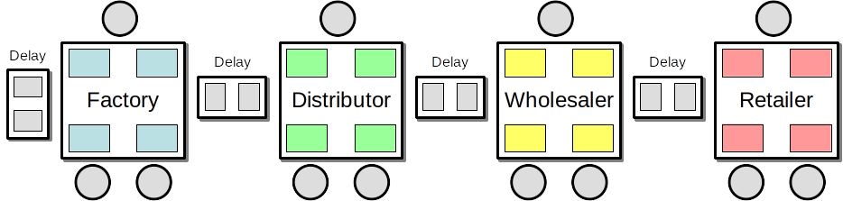

Every game has the same layout that shows four different areas (see figure):
- The place for incoming orders (inbox) – coming from the downstream stage
- The place for outgoing orders (outbox) – going to the upstream stage
- The place for incoming deliveries (receiving) – coming from the upstream stage
- The place for outgoing deliveries (dispatch) – going to the downstream stage

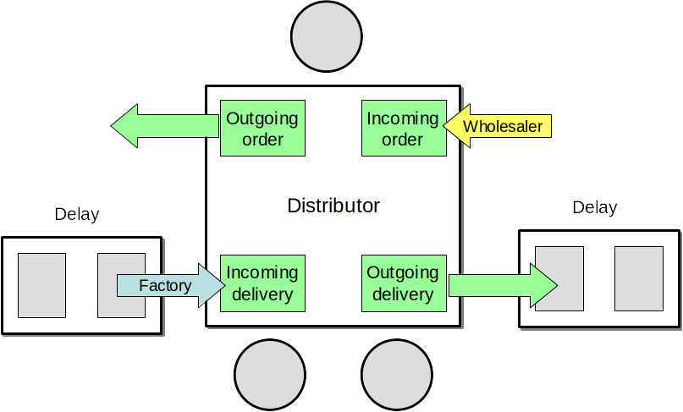
Deliveries are “on the road” for 2 weeks (lead time); production also takes 2 weeks. This lead time delay is represented by 2 two extra fields between the tables that hold the deliveries and are moved forward in each week.

General playing procedure
The game runs in weeks and it starts in week 1. In each week, each supply chain group has to proceed with the following steps:
- Receive new deliveries and update the play sheet (“incoming” and “available”).
- Receive orders in the inbox and update the play sheet (“new order” and “to ship”)
- Calculate the total amount that will be shipped (“your delivery”), note down the amount, and place it in a box in the dispatch area on your table.
- Agree on a new order amount, note down the number, and put it in an envelope in the outbox field.

The goal

Your goal is to minimize your cost!
(Remember that you compete against the same stage in the other supply chains – retailer against retailer, distributor against distributor etc.)
There are two different kinds of cost:
- Inventory cost: Items in stock cost € 0,50 per week in holding costs.
- Backorder cost: If an incoming order cannot be (fully) fulfilled, items are outstanding and have to be put on “backorder” to be fulfilled in the following week(s). Each item on backorder costs € 1,00 per week.

What is a backorder?
If an incoming order cannot be fully fulfilled due to a lack of available items in the inventory, items go on backorder. In this case your inventory is empty and a number of items have to appear as backorder in your play sheet.

What happens in the next week?
In the following week, you will add the old backorder to the new incoming order to calculate the amount “to ship”. Again, if the available inventory is too little to fulfil the amount “to ship”, items have to be put on backorder and will cost $ 1,00 per item.

Some general rules
- No communication is allowed between supply chain groups, supply chain groups must not talk to each other at any time!
  - Especially the customer demand is only known to the retailer.
- If stock is available, an order has to be fulfilled.
- Every order has to be fulfilled, either in the current week (if enough stock is available) or in one of the next weeks (items go on backorder).
- Either the inventory or the backorder, one of them is always zero (0)!

Each week’s steps in detail – (This is automated for our activity)

1. Incoming delivery (new delivery)
Add incoming delivery to controlling sheet and update “available”. Add incoming delivery to old inventory to get the available number of items in stock.
Available = Inventory (last week) + Incoming

2. Incoming order (new order)
Open envelop and enter the order amount to your controlling sheet and then calculate the amount that has to be shipped. Take into account any backorders.
To ship = backorder (last week) + New Order

3. Prepare delivery
Figure out the amount that will be delivered to the next stage and write the number on a delivery slip, fold it, and place it into a shipping container.
If the amount to ship exceeds the available stock, then you have to deliver whatever is available, otherwise you will simply fulfil the order.
If (To ship) > Available then your Delivery = Available
If (To ship) < Available then your Delivery = To ship

4. Calculate backorder
If the outstanding orders (“to ship”) cannot be fulfilled, then put the remaining items on backorder.
If (To ship) > Available then Backorder = To ship – Available
Else Backorder = 0

5. Calculate inventory
The new inventory is simply the available stock minus the delivery that is made. It is zero in case the outstanding orders (“to ship”) cannot be fully satisfied (in case of backorders).
If (To ship) > Available then Inventory = 0
Else Inventory = Available – To ship

6. Place new order
Discuss and place your new order (or production order). Note down your order using an order slip and fill it into your controlling sheet, then place your order in the outbox using an envelope.

